Free Youtube views for an unlimited number of your videos! Boost your video's popularity using their simple and free method! Or, buy Youtube views and other services here.

[ythunder.com](https://ythunder.com/) has free & open registrations.

Looking for the best site to buy cheaper, genuine [YouTube views](https://ythunder.com/) today is a lot like looking for a needle in a haystack. From the risk of bumping into sweet-talking, money-hungry scammers to actually splurging on fake, bot-generated views, the dangers are way too much to fathom. And for someone Free Youtube views：[ythunder.com](https://ythunder.com/)

doing this for the first time, you definitely can’t be any safer.

The risks get a notch higher when you discover that the once-most reputable sources of **cheaper** [**YouTube views**](https://ythunder.com/) have lost their rapport, all thanks to [YouTube](https://ythunder.com/)’s revamped Ranking System. The noose is so tight today that even if the views are from humans, they may still fail to convert.

**And it’s a no joke, by the way!**

See, [YouTube](https://ythunder.com/) now pays close attention to how genuine your views are. Simply put, they have a super-smart algorithm that goes deeper, analyzing the weight of your views. It checks their origin, the sentiments behind them, and whether they are rich, high retention views or not.

Poor quality views, especially those generated automatically using a Bot, are the first to go down followed by those whose click-through rates are wanting. Eventually, when you expect your channel to rank higher, this giant video-sharing website will have flagged it without your knowledge. And that’s when it starts monitoring your view patterns.Free Youtube views：[ythunder.com](https://ythunder.com/)

**Well, that’s the situation today, sadly. But all isn’t lost**

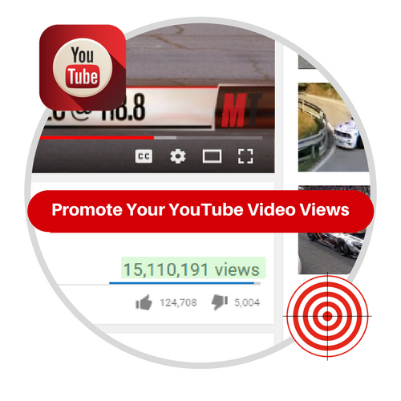

In this niche, the term “You get what you pay for” makes a lot of sense, especially because no two views are similar. But the above stated revelation shouldn’t dent your dreams of being a [YouTube](https://ythunder.com/) Wizard with thousands of subscribers and a million views on a video, or more. Nearly every [YouTuber](https://ythunder.com/) buys views nowadays and rightly so because it is a lot sensible and convenient to solidify one’s base.

From as little as $10, or less, they get decent ROIs on top of several other benefits. [YouTube](https://ythunder.com/)’s Terms of Service isn’t against buying genuine, high-converting [YouTube views](https://ythunder.com/) at all, especially if they are from humans.

Whether they are delivered in a lump sum or gradually, you can be sure that these real views will increase the overall number of views you do receive. [YouTube views](https://ythunder.com/) can dramatically boost a video’s overall rank and effectively help a little-known [YouTuber](https://ythunder.com/) be a star. With such reasons, you should be confident that, with just the right source of real, targeted [YouTube views](https://ythunder.com/), good tidings will be on your way.

**Need to** [**buy YouTube views**](https://ythunder.com/) **of the best quality on the internet today?**

While shopping for views for your beloved [YouTube](https://ythunder.com/) videos, make sure you go for real, genuine and high retention views. For someone who has never bought [YouTube views](https://ythunder.com/) before, the prospect of getting scammed or buying fake, low-quality views is scary.

**You can tell low-quality** [**YouTube views**](https://ythunder.com/)

Low-quality [YouTube views](https://ythunder.com/) often have characteristics that differentiate them from the real, high-quality ones. Mostly, they originate from the same area in Eastern Europe, especially Russia and have a retention rate that’s less than 10%. [YouTube](https://ythunder.com/) will also tell that they are fake using their often similar IP address, cookies and browsers.

[YouTube views](https://ythunder.com/) considered to be of a higher quality also have several unique features. They majorly come from the US, UK, and Australia and have a retention rate of between 70% and 100%. Furthermore, each of them will have a unique IP address and diverse cookies.

**Their prices are questionable**

Going by the experience of several [YouTuber](https://ythunder.com/)s, websites selling [YouTube](https://ythunder.com/) services cheaply tend to be scammers. They could also be using Bots to deliver low-quality and low-retention views and thus sees no problem generating them en-masse. Moreover, these fake [YouTube views](https://ythunder.com/) often get purged after 24 hours.

For me, it would make sense to spend a little more than the average charged by a shoddy third-party seller of these services and get quality, credible and top-notch services. This way, you will have a bigger bang for your buck without putting your [YouTube](https://ythunder.com/) videos at risk.

**What to look for when hunting for the best, top-quality views for your** [**YouTube**](https://ythunder.com/) **videos**



As acknowledged in the introductory paragraph of this post, it may take weeks of hard work, diligence, and carefulness to precisely pinpoint who sells [YouTube views](https://ythunder.com/) of the best quality. Thankfully, there are several pointers to use and hopefully get the right guy to buy from.

One aspect to watch out for is someone who promises to provide them on a dirt-cheap price. You naively rely on a random stranger you’ve met online only to burn your fingers and jeopardize the reputation of your channel.

And so, the best way is to go a long way, test each of the countless sellers until you discover a couple who are legit and stand by their word. Perhaps you are wondering what a [YouTuber](https://ythunder.com/) ought to look out for when looking for genuine [YouTube views](https://ythunder.com/) to buy.

Let’s look at them:

* **Do they guarantee high-quality, high-retention views?**

Anyone can generate views and deliver them within the stipulated period. The difference and perhaps the most crucial aspect to consider is the quality of each view promised.

**Spammy, low-quality views**, according to the algorithm, can be identified from their retention, origin and the engagements they create. If a view actually originated from a real human being, it must have lasted for more than ten seconds, especially if the video is a minute long. But if the pattern of a majority of the views is similar; they stuck around for a couple of seconds and left, then the smart algorithm will perceive them as fake.

**As for the origin of the views**, ordinary [YouTube](https://ythunder.com/) video targeting viewers of a particular dialect should get a majority of its views from where the target group is found. If a clip made in English, for example, registers of 75% of its views from Russia, China or Ukraine, [YouTube](https://ythunder.com/) will understandably take that for fake, low-quality views.

Lastly, quality, **targeted and high-retention views automatically trigger engagements**. What this simply means is, viewers will hit the ‘Thumbs-up’ or ‘Thumbs-down’ button and leave a comment if they can relate with what the video is about. On the contrary, [YouTube](https://ythunder.com/) will suspect the source of your views if they don’t elicit any notable amount of engagements.

Considering that your source provides these three vital aspects and indeed delivers them, then you have no reason to lose sleep tonight. Remember, it isn’t hard to analyze your metrics and determine whether they actually are high-quality views or not.

* **Delivery: how fast and reliable will the views start streaming in?**

From what’s now an industry standard, views ought to be delivered as soon as possible, mostly in less than 24 hours. There are a couple of reasons to back up this, but the major one is so that the buyer’s primary objectives of getting more views are met.

See, it’s only after a video gets the initial views that the rest of the organic views starts to come in. Speedy delivery of safe, high-quality human views also ensures the buyer can recoup on the initial investment as soon as possible. Bizarrely though, it gives the buyer adequate time to judge if the third party seller is legit or not.

But if you wouldn’t prefer to receive the entire batch of views in one go, under 24 hours, you may still ask them to send them in at a slow pace. You might, therefore, have to extend the period to cover two weeks or less. Regardless of your arrangements, however, it is crucial to mention that, contrary to the public perception out there, getting large volumes quickly isn’t a sign of fake, low-quality services.

* **Customer support**

You are a client, just like any other before or after you. And you deserve to be treated with respect and dignity just as your order is being processed. Excellent customer support is mandatory and rightly so since this business heavily dwells on honesty and integrity.

Under this feature, therefore, one of the factors to consider is the ease of accessing their support desk in case you need to. Accessibility is determined by such things as how soon they will work on your request, whether they are even easy to contact in the first place and so forth.

* **Money-Back Guarantee**

This is yet another significant factor, and I highly doubt if you will ignore it. Basically, a 100% money-back guarantee should give you the confidence that your money is safe in case things go south. It also helps to certify that the views are of just the right quality.

Several third parties have this clause as part of offers, and there are others which don’t. And so, when push comes to shove, and you are torn between two sellers with similar packages, opt for one that is likely to give you back your money.

* **Lastly, use independent reviews**

An honest review, especially on who provides [YouTube views](https://ythunder.com/) of the best quality out there is like a pot of gold; it is priceless. To get this honest referral, you must be willing to ask around, check on Facebook and the popular forums or even post a question on Quora.com.

You may also trust what any great review website recommends, though you can take them with a pinch of salt. All these hassles can take you a day or two and save you a ton. It is, therefore, imperative that you consider reviews and referrals too.

**IMPORTANT: Prices can deceive; don’t fall for them!**

Out of all the factors you may use to choose one or more third parties to [buy YouTube views](https://ythunder.com/) from, never should you base them on their prices. Cheap is expensive and nowhere does this statement make sense more than when it pertains purchasing views for your [YouTube](https://ythunder.com/) videos.

They could be promising lots of views for just pennies and you immediately see it as a pretty good deal. Don’t burn your channel for pennies bro! Watch out, scammers are known from their ridiculously low prices too.

**So, where can you buy cheaper, real human** [**YouTube views**](https://ythunder.com/)**?**

A third party with high-quality, high-retention [YouTube views](https://ythunder.com/), speedy delivery, and the all-important money-back guarantee is the best fit. But of course, among them are a couple of fictitious ones who will offer nothing, but spam views. You must be extra careful and watch out not to fall for their trap.

There are countless websites, all of them promising to deliver genuine, high-retention and targeted views on the cheap. But being all-careful requires choosing the risks worth taking while taking your time to determine whose reputation is without blemish.

Mostly, you may have to carefully decide who to buy from based on the points as mentioned throughout this post. Consider following the below guidelines as well:

* **Don’t be on a rush yet – make a call**

Before you rush into placing an order, it is recommended that you take some time and talk with them directly. It is a simple method that helps quell any suspicions you could be having. Furthermore, a mere phone call with the third party will give you an idea of the type of [YouTube views](https://ythunder.com/) you will receive.

* **You can also rely on in-depth expert reviews online**

Unbiased reviews on Facebook or Twitter tend to paint a clear and accurate picture of what you would be dealing with. On any of the two social media channels, you should be smart enough to visit their page and check the kind of comments and complaints being posted. From what you’ll gather, making the correct decision will not be hard.

Facebook Groups also could be of profound importance in shedding more light on other things to watch out for. It’s a place where you might find cheaper, more credible [YouTube](https://ythunder.com/) view merchants without breaking a sweat.

* **If you won’t find one to buy views from, even after all that hassle, don’t worry**

Some review websites are the real lifesavers and have a reputation for never recommending a seller of fakes. For the site to win your trust, however, it should be operating independently and only relies on ads. Basically, it shouldn’t be relying on affiliates.

One strategy I often apply when going through the third party [YouTube](https://ythunder.com/) view sellers recommended there is analyzing them, one-by-one. You will find that there could be one or two which are thoroughly mentioned for their exemplary services. One of these review websites worth giving a shot is ythunder – I like it because it backs up its claims with results of genuine tests they did.

Some websites like ythunder.com for example, when it’s mentioned severally across the board, you will have no reason to shy away from buying from them. But even if it has been said just once, but has a pleasant review elsewhere online or on social media, you will immediately feel confident engaging them.

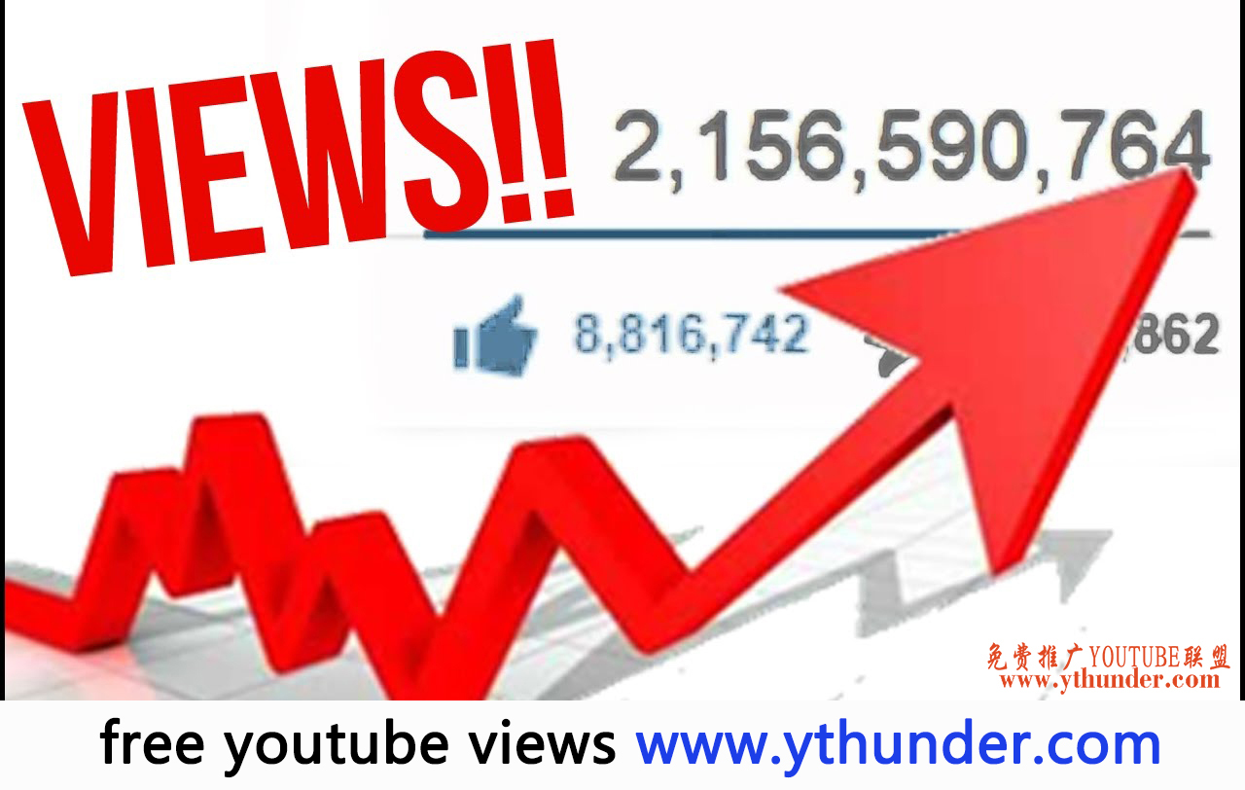

* **Or, just place a risk-free order**

To save you all the troubles of seeking someone’s opinion or trawling the internet for a day, you can simply take their cheapest offer and place a simple order. You create a dummy channel for experimentation purposes and monitor, study and make the final decision based on what you receive. From the views your dummy [YouTube](https://ythunder.com/) channel receives, you will be able to gauge whether they are worth your bucks or not.

**So, where can you get the best, high-quality** [**YouTube views**](https://ythunder.com/) **today?**

In conclusion, the best answer to this question is squarely upon you. Scour the web, ask your colleagues or do your tests on the sites and, by the end of them all, you will have found the right [YouTube views](https://ythunder.com/) to buy. In all you do, however, remember that [YouTube](https://ythunder.com/) has nothing against targeted, high-quality and high retention views.Free Youtube views for an unlimited number of your videos! Boost your video's popularity using their simple and free method! Or, buy Youtube views and other services here.

[ythunder.com](https://ythunder.com/) has free & open registrations.